**Smart Bridge Externship Project**

**Domain : Modern Application Development (Java Spring boot)**

Group Number : 190

Group Members :

1. Aaryan Chaurey : 20BCE10316
2. Madhur Agarwal : 20BCE10677
3. Pavan Kunte : 20BCE10646
4. Utkarsh Singh : 20BCE10111

**Online Movie Ticket Booking System**

**Introduction**

**1.1 Overview**

The Online Movie Ticket Booking System project is a web application that basically manages the ticket booking process for movies, providing an interface for the user to book movie tickets in a more easy and friendly way. At the front end, we have built an attractive user interface, and at the back-end Spring Boot and MySQL Database.

Our project has two actors, User, and Admin which both have their different scopes and authorization.

The project proceeds through a sequence of well-designed forms provided with validations to Ensure consistency, reliability, and most importantly correctness of information fed into the database.

Admin would have some rights reserved with respect to the application.

**1.2 Purpose**

The advancement in Information Technology and internet penetration has greatly enhanced

various business processes and communication between Users and Talkies. This Online

Movie Booking System is developed to provide the following services:

* **Enhance Business Processes:**

To be able to use internet technology to project to the global world instead of limiting them services to their local domain alone, thus increasing their return on investment (ROI).

* **Online Movie Booking:**

A web application in which Users can register and find out different movies with respect to different Talkies in a particular city. In the end, a user could make a payment and receive the acknowledgment of the booking.

**Literature Survey**

**2.1 Existing problem**

The existing system of online movie ticket booking system is fully functional and secure in terms of payment gateway. There is a procedure in the existing system where a business Advertise be shown so that the business could grow. This system is globally spread and doing well.

**2.2 Proposed solution**

* **Product functionality:**

The movie Ticket Booking System provides features for admin and Users. It includes several functionalities describe below:

* **Searching Movies:**

Users can view the required using filters by city, talkies, and Movie name.

* **Booking a Movie Ticket:**
* User can book as many tickets as he wants sitting at home means over the internet. And could pay the money online or at the booking desk in the theatre.
* **Adding A Theatre by Admin:**

An Admin has the right to add theatre with a particular city. Admin can also delete the theatre.

* **Adding A Movie Theatre by Admin:**

An Admin has the right to add movies with a particular city. Admin can also delete the movies

**Theoretical Analysis**

**3.1 Block diagram**

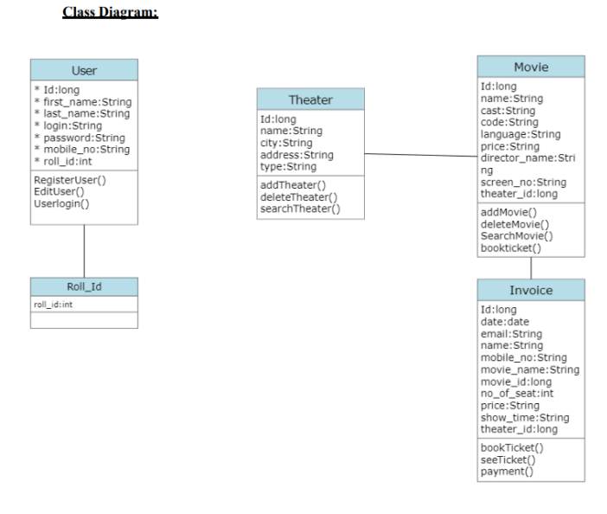

**3.2 Hardware / Software Designing**

* Operating Environment:
* Server Side:
* Processor: Intel core i5 11 Generation
* SDD: 512GB Disk Space
* RAM: 8GB
* OS: Windows 10
* Database: MySQL 8.0
* Client Side (Minimum Requirement):
* Processor: Intel Dual Core
* SDD: Minimum 8GB Disk Space
* RAM: Minimum 4GB
* OS: Windows 7, Linux

**User Interfaces:**

• All the users will see the same page when they enter in this website. This page

asks the users for a username and a password.

• After being authenticated with the correct username and password, the user will be

redirect to their corresponding profile where they can do various activities.

• The user interface will be simple and consistent, using terminology commonly

understood by intended users of the system. The system will have a simple

interface, consistent with a standard interface, to eliminate the need for user training

of infrequent users.

**Hardware Interfaces:**

• No extra hardware interfaces are needed.

• The system will use the standard hardware and data communication resources.

**Application Interfaces:**

OS: Windows 11

**Web Browser:**

The system is a web-based application; clients need a modern web browser such as

Mozilla Firebox, Internet Explorer, Opera, and Chrome. The computer must have an

Internet connection in order to be able to access the system.

**Flowchart**

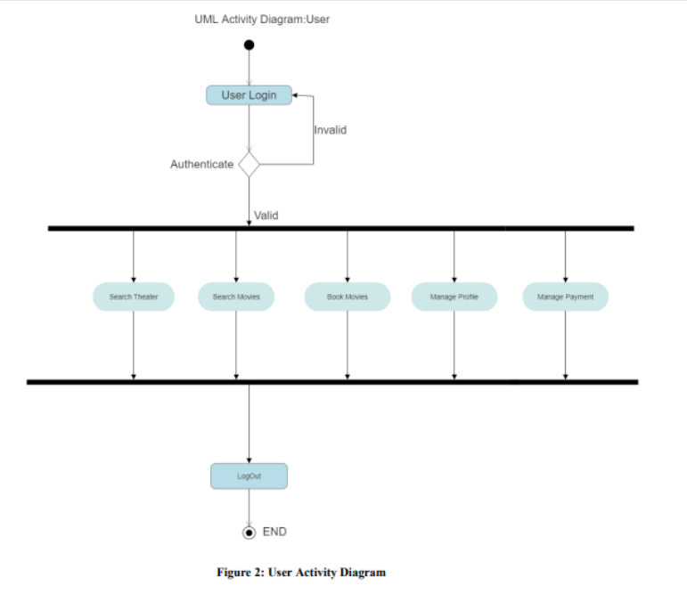

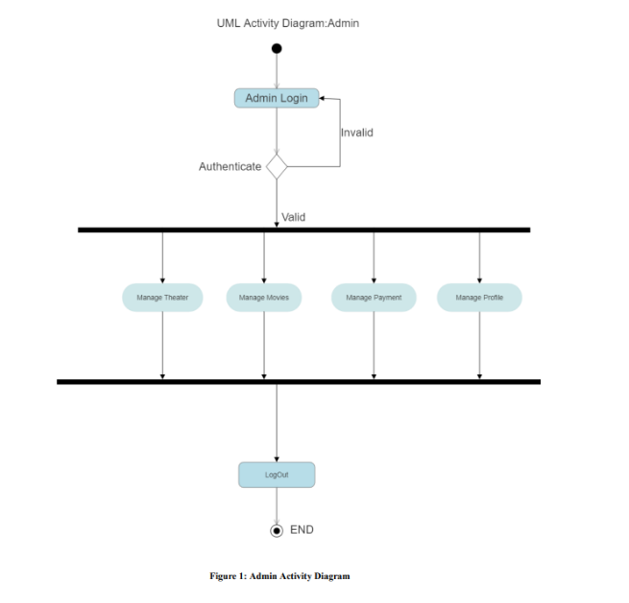

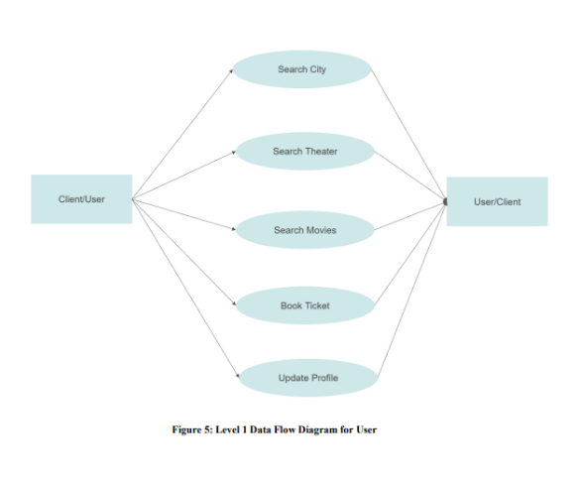

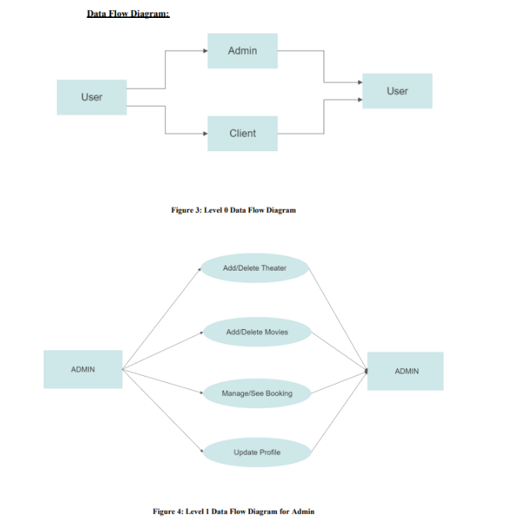

**Result**

**Home Page**

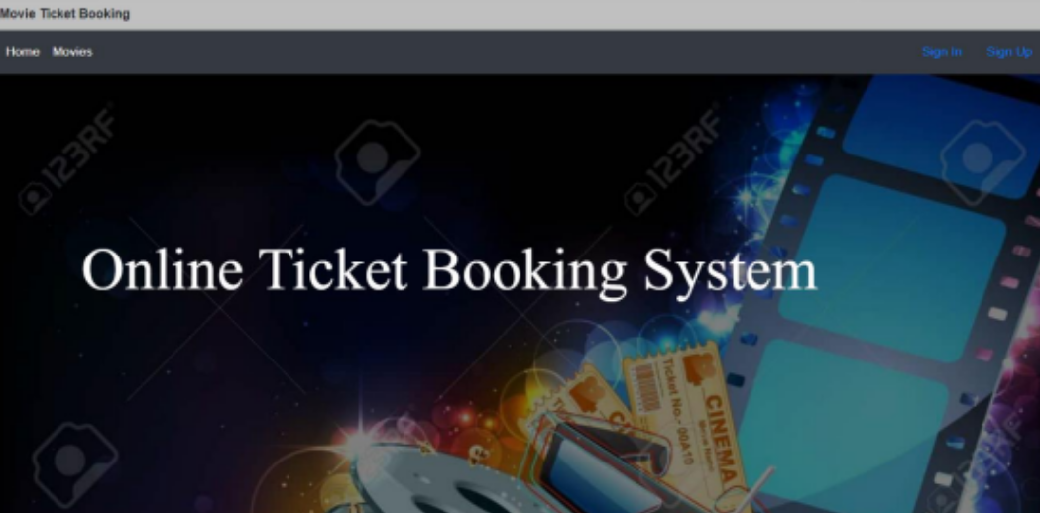

**Login Page**

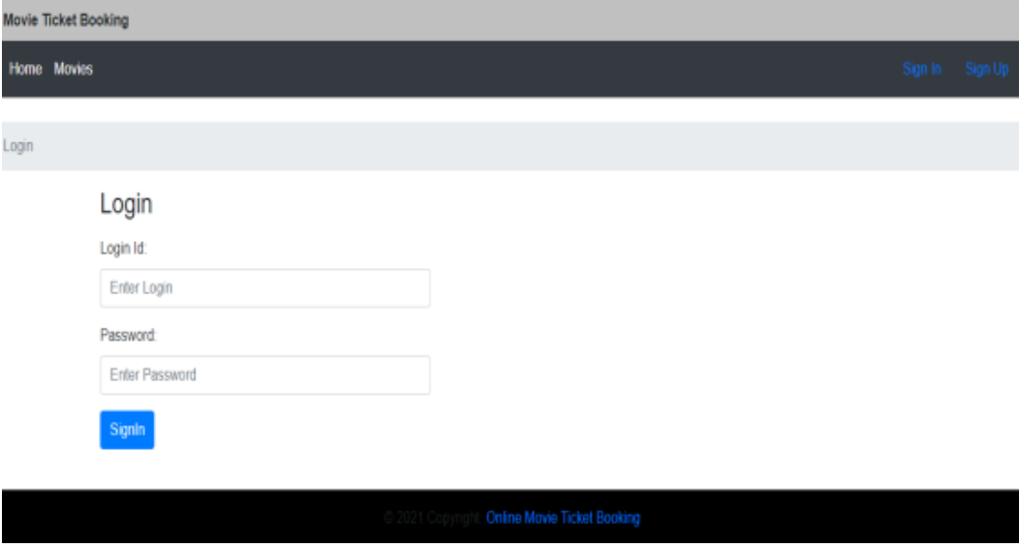

**Admin Home Page**

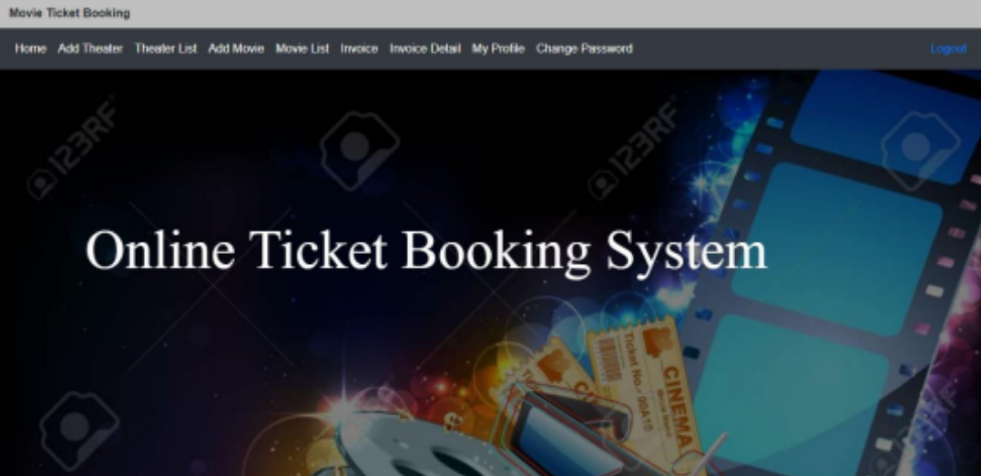

**Admin Add Theatre Page**

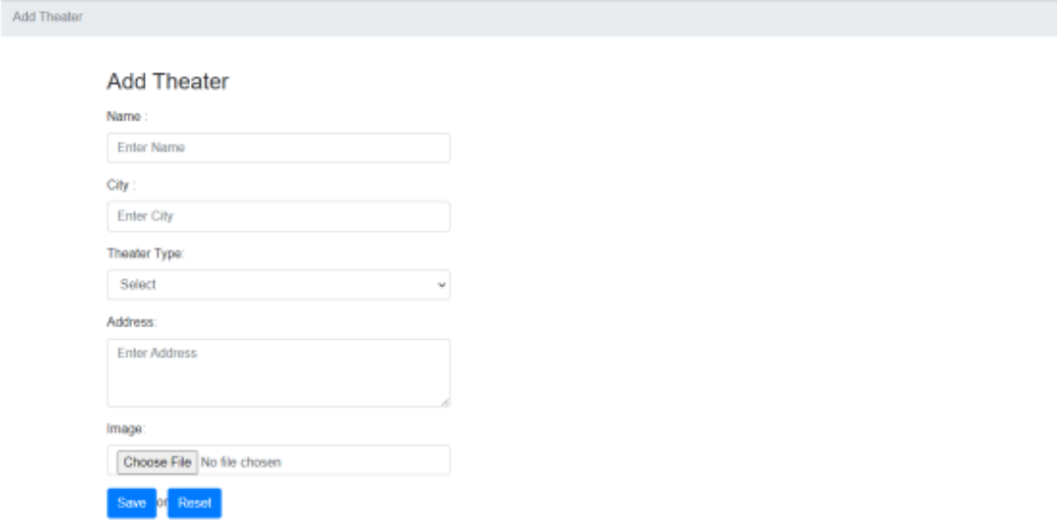

**Admin Add Movie Page**

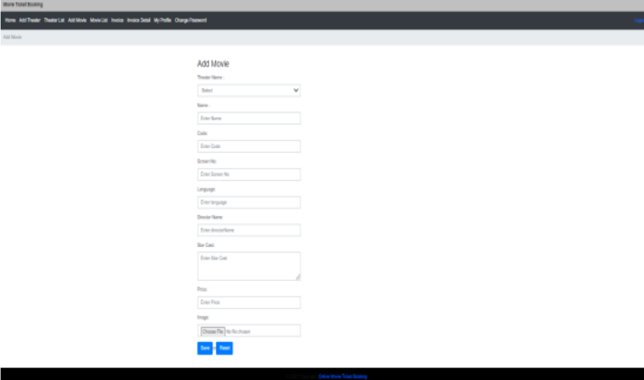

**Advantages and Disadvantages**

**Advantages:**

* Rapid Development: Spring Boot provides a streamlined development experience with its convention-over-configuration approach.
* Spring Ecosystem: Spring Boot leverages the rich ecosystem of the Spring framework, providing access to a wide range of libraries, modules, and tools.
* Developer-Friendly: Spring Boot offers extensive documentation, a vast community, and a large number of resources.

**Disadvantages:**

* Learning Curve: Spring Boot has a learning curve, especially for developers who are new to the Spring framework.
* Configuration Complexity: Although Spring Boot simplifies many aspects of configuration, complex application setups can still require detailed configuration.
* Performance Overhead: Spring Boot introduces some performance overhead due to its layered architecture and auto-configuration capabilities.

**Applications**

This project traverses a lot of areas ranging from business concept to computing field, and required to perform several researches to be able to achieve the project objectives. The area covers include:

• Movie Industry: This includes study on how the Movie Industry is actually being work, process involved and opportunity that exist for improvement.

• J2EE Technology used for the development of the application.

• User (General people) as well as the Theatre staff will be able to use the system effectively.

• Web-platform means that the system will be available for access 24/7 except when there is a temporary server issue which is expected to be minimal.

**Conclusion**

Online Movie Ticket Booking System puts forth the model of actual working of a movie booking system. Administration, management, payment calculation, sending acknowledgement, Theatre customer management, etc. similar to a movie environment are the key features of our project. User can access services and functionalities from all over the world without any time bound which give a certain kind of for comfort and closeness.

**Future Scope**

This project can be enhanced further by adding the security in the payment gateway, so that the data and transaction of the user to the respective bank will be efficient and secure. Also, in future user can select the seat for booking ticket. Again, another addition could be the commercial advertisement on the website so that there will be more business option which will be the side products of the application. Message and Email alerts for various happenings in the booking system can be added to the system so that users do not miss the updates and happenings in the ticket booking system.

**Bibliography**

1. www.w3school.com
2. www.javatpoint.com
3. www.TutorialPoint.com
4. www.geeksforgeeks.com